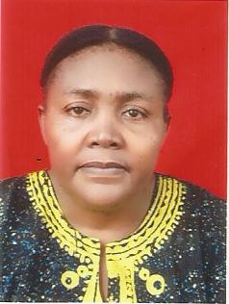
STAFF PROFILE

Name: Dr Mrs Ekwutosi Beatrice Oluah
Faculty: Agriculture
Department:Home science and management
Designation:Lecturer 1
Staff Number:UNP/SS.7180
Email: ekwutosi.oluah@unn.edu.ng
Phone number: 07033863177
BIOGRAPHY:
Date of Birth:10TH FEBRUARY 1966
Town of Origin: UGWUEMELGA :Awgu
State of Origin:Enugu
Area of Specialization:CLOTHING AND TEXTILES
Responsibilities
Teaching:HSM 261,262,361,363,461,462,465,463,467,455,
Membership of Professional Bodies.
Home Economics Research Association of Nigeria (HERAN)
International Federation of Home Economists. (IFHE)
Publications
- Enhancing economic status of dress makers through cooperatives
- Strategies for improving the children's clothing practices of mothers in Enugu state.
- Strategies for meeting the clothing needs of children in Enugu State.
- Dimensional Stability of Selected Nigerian Wax Fabric (in Press)
ConferencesAttended
HERAN CONFERENCE 2007 TILL DATE
IFHE 2017. UYO

