PERSONAL INFORMATION
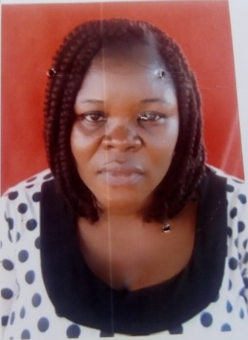
Name: Asogwa Joy Nneka
Department: Home Science and Management
Faculty: Agriculture
Designation: Laboratory Assistant
Email Address: joy.asogwa@unn.edu.ng
Phone Number: 08032427187
Staff Number: JS/13549
Responsibility: Assisting in Laboratory Duties
Brief Biography
Date of Birth: 24th Feburary 1983
Marital Status: married
Spouse: Mr Chukwu Sunday Micheal
Next of kin: Chukwu Frank Kelechi
Permanent Home Address: No 1 B Onuiyi Link road Nsukka
Contact Address: Department of Home Science and Management UNN
State of origin: Enugu State
Number of children: Three (3)
Academic/Qualification: FSLC , WAEC

