STAFF PROFILE
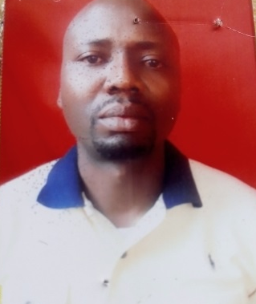
Name: Ogbonna Ugochukwu Paul
Department: Home Science and Management
Faculty: Agriculture
Designation: Higher Technical Officer
Email Address: ugochukwu.ogbonna@edu.ng
Phone Number: 08030403360
Staff Number: UNP/SS/14185
Brief Biography:
Ogbonna Ugochukwu Paul , was born in Nsukka , hail from Iheakpu Awka in Igbo Eze-South LGA of Enugu State Nigeria on 20th of July 1977. He began his academic pursuit in 1983 at Onuiyi Primary School. In 1989 he gained admission into St. Theresa`s Collage Nsukka and passed out with WAEC in 1995 . He started his University education in 1997 and obtain Bachelor’s of science in Home Science and Nutrition 2001. He did his compulsory 1year NYSC program at Ibusa General Hospital Delta State 2002. He is married to Ogbonna Gloria with five children. He represented his ward as a counselor for 4years (2011- 2015 )in Igbo Eze-South legislative council. Ugochukwu joined the work force of the University of Nigeria in 26th January 2018.
Area of Specialization: Food and Nutrition.
Membership of Professional Bodies: Nutrition Society of Nigeria
Publication: Child abuse and Neglect in Nsukka Urban( undergraduate project)

